CCR - Identifying and Handling Medicare Part B Calls

General Information
Identifying Medicare B Eligible Beneficiaries
Handling a Medicare B Call
Related Documents

Description: This document details the steps to help a Customer Care Representative (CCR) identify Medicare Part B benefits and when to transfer calls to the Medicare Part B team, when appropriate.

General Information
Medicare Part B (Medical Insurance) helps cover doctors' services and outpatient care. It also covers some other medical services that Part A does not cover, such as some of the services of physical and occupational therapists, and some home health care. Part B helps pay for these covered services and supplies when they are medically necessary.

Notes:
- The Medicare B team is part of the PBM and not CMS/1-800-MEDICARE (1-800-633-4227). Questions related to the ‘red/white/blue’ card or durable medical equipment should be referred to CMS.
- Customer Care Representatives cannot file Medicare Part B grievances on behalf of beneficiaries. To file a grievance, the beneficiary must contact 1-800-MEDICARE (1-800-633-4227). For Commercial beneficiaries, to file a complaint, submit the appropriate RM Task.
- All Med-B Conflicts with a PSC conflict, MUST be called on to the beneficiary/patient to identify exact/estimated amount of medication on hand.

Refer to the following work instruction for the appropriate guidelines: Approved Referral Guidelines to Medicare and Social Security.

Low Income Cost Share (LICS) does NOT apply to Medicare B.

Top of the Document

Identifying Medicare B Eligible Beneficiaries
A number of indicators and messages are included in PeopleSafe and the CIF to help CCRs identify Medicare B eligible beneficiaries.
The tables below list locations and the Medicare B information located within them:

CIF:
Location | Medicare B Information
CIF | The CIF will indicate if the plan is an MAPD Plan.  Refer to the following sections in the CIF for MAPD information:  - Client name description  - Need to Know  - Plan Design Highlights  Note: If the client is an MAPD plan, calls should NOT be transferred to the Medicare Part B team, as these claims are processed through the plan and not separately by Medicare B.

PeopleSafe:
Screen | Medicare B Information
Main screen | The Main screen will include a Medicare B: ENROLLED or Medicare B: Pending indicator when the beneficiary is eligible. Note: These indicators are only visible for Commercial clients.  - Medicare B: Enrolled indicates that the necessary paperwork (AOB) is on file and the beneficiary is enrolled in Medicare Part B.  - Medicare B: Pending may indicate an AOB is still required.  - AOB at retail needs to be signed and given to retail pharmacy  - AOB at mail needs to be signed and mailed to address provided in the letter  Commercial Account Example:  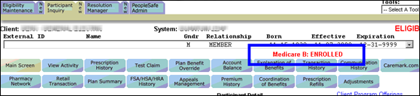  Note: If the account is for a Medicare Part D client, the CCR will only see the existing Medicare D Eligible indicator.  - Only one indicator can be shown on the Main screen with Medicare Part D overriding Medicare Part B.  - However, the beneficiary may also be eligible for Medicare Part B.
Test Claim | If the client has opted into Medicare B COB, the Test Claim screen will include an informational message: Med B Secondary processing may apply.  Do NOT use the Med B checkbox under Optional Criteria.  - It will result in incorrect pricing results.  Commercial Account Example:  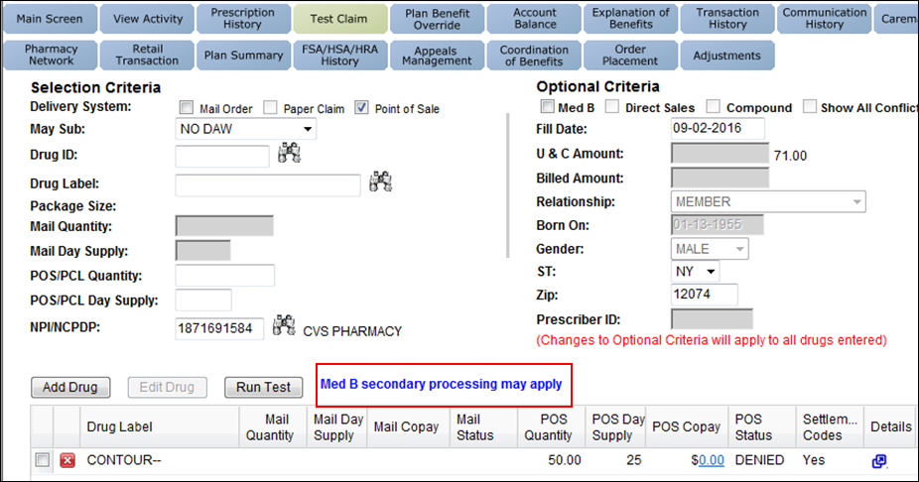  Medicare D Account Example:  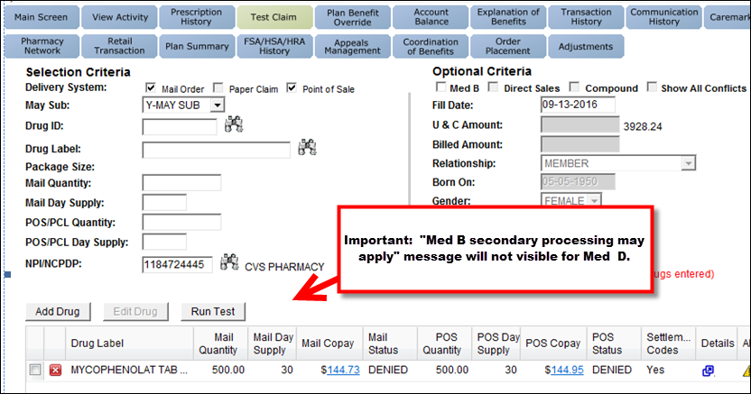  The Test Claim Results may include a Medicare Part B-related settlement code:  Commercial Account Example:  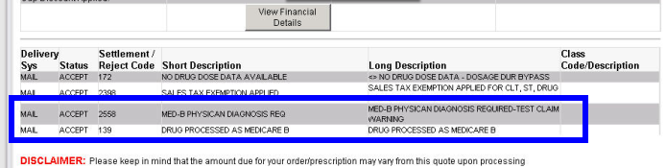  Medicare D Account Example:  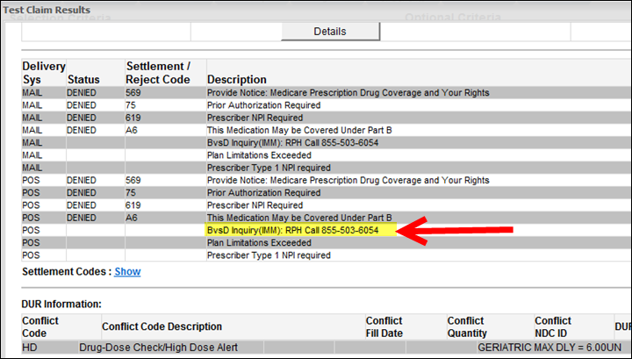  - It will display a PREAUTH REQUIRED settlement code instead.  - The MED D CCR should initiate the Prior Authorization process.  OR  - If the beneficiary insists that Medicare Part B should cover the medication, the CCR will contact the Medicare Part B team.  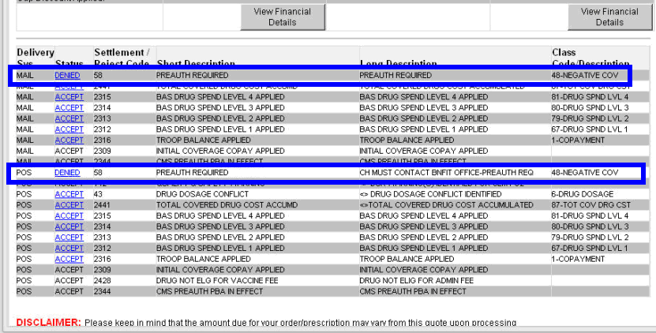
Prescription Refill | The Refill Snapshot on the Prescription Refill screen includes a Med B column to indicate if the drug is Medicare Part B eligible.  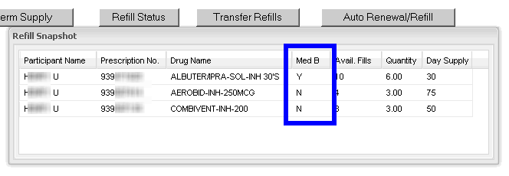
Maintenance Choice Transfer | The Maintenance Choice Transfer screen will also include a Med B column to indicate if the drug is Medicare Part B eligible.  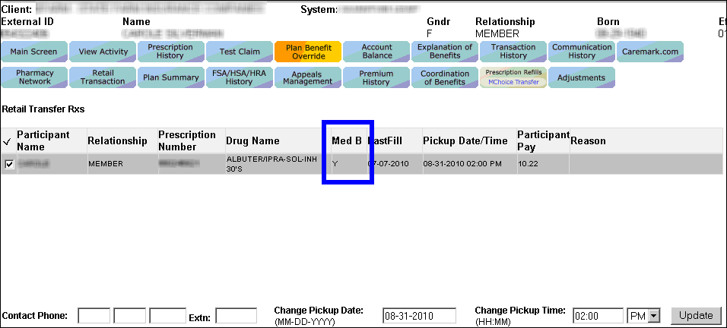
View Problems | When checking the status of an order, check:  - View Problems, Order Level and Prescription Level Comments.  MedB Attestation – The PBM’s pharmacy reaches out to the beneficiary to verify the day supply on hand prior to releasing a Medicare B order.  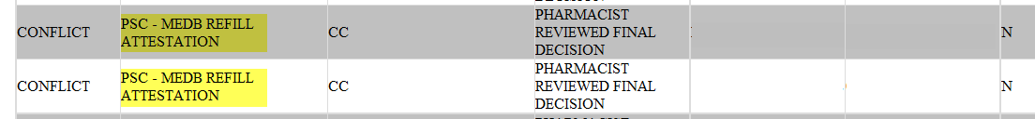

Top of the Document

Handling a Medicare B Call

When addressing a Medicare Part B call, the CCR will:
Step | Action
1 | Ask probing questions to determine if the beneficiary is eligible for Medicare Part B and is calling about a Medicare Part B issue.  - Refer to the Identifying Medicare B Beneficiaries section of this document to assist with this process.
1 | If the beneficiary is… |  | Then…
1 | NOT Medicare Part B eligible |  | Handle the call as normal.  - The call should NOT be transferred to the Medicare Part B team.
1 | NOT Medicare Part B eligible, but the beneficiary’s account was flagged in error |  | Contact the Medicare Part B team at 1-866-804-5880 to have the flag removed.
1 | Asking specifically about Medicare Part B eligibility or drug coverage |  | Proceed to the next step.
1 | Medicare Part B eligible, and is asking about drug coverage |  | Determine if the drug in question is covered under Medicare B by running a test claim.  - See Test Claim information above.
1 |  |  | If… | Then…
1 |  |  | The test claim results indicate it is a Medicare Part B drug | Proceed to the next step.
1 |  |  | The test claim results do not mention Medicare Part B | Handle the call as normal, following the client’s plan guidelines.  Proceed to Step 3.
1 | Inquiring about a Medicare Part B covered medication. Refer to Medicare B Medication List. |  | Proceed to the next step.  Note: If the medication is not listed, handle the call as normal. The call should NOT be transferred to the Medicare B Team.
1 | Inquiring why a prescription did not process under Medicare Part B |  | Advise the beneficiary:  - The diagnosis code provided by their prescriber is an ineligible code that is not a covered diagnosis for Medicare Part B.  - Beneficiary can contact their prescriber and advise the diagnosis code is incorrect or may fill their prescription at a retail pharmacy.  The order will attempt to process under the beneficiary’s commercial plan.  Place the following note in both the Notepad and Comments: MDB, <patient name>, <drug name>, dx <code>, ineligible dx x mdb faxback. Med B process complete, submit through Commercial Plan, Ou #<XXXXXXXXXX>/Rx # <XXXXXXXX>.
1 | Wanting to OPT out/in of Medicare Part B  Note: EGWP and certain other clients may not have the flag turned on. |  | Document the beneficiary has chosen to OPT out/in of Medicare Part B.
1 | Asking about receiving only a 30 day supply, when their prescriber wrote for a larger quantity |  | Advise the beneficiary according to Medicare Part B guidelines only a 30 day supply is allowed.  - The call should NOT be transferred to the Medicare Part B team.
1 | Asking about diabetic testing supplies under Medicare Part B |  | Advise the beneficiary, the PBM was not selected by Medicare to supply diabetic testing supplies. The beneficiary can contact their state SHIP counselor to locate a DME/mail order provider for diabetic testing supplies.
2 | - Warm transfer the call to the Medicare Part B team at 1-866-804-5880.  - Document and close the call according to current policies and procedures.  - Refer to the MED D - Call Documentation work instruction.  Note: All Med-B Conflicts with a PSC conflict, MUST be called on to the beneficiary/patient to identify exact/estimated amount of medication on hand  Log Activity  701= Eligibility Verification
3 | Ask if there are any other benefit questions.
3 | If… | Then…
3 | Yes | - Address any benefit issues.  - Document and close the call according to current policies and procedures.  - Refer to the MED D - Call Documentation work instruction.  Log Activity  701= Eligibility Verification
3 | No | Document and close the call according to current policies and procedures.  - Refer to the MED D - Call Documentation work instruction.  Log Activity  701= Eligibility Verification

Top of the Document

Related Documents
Parent SOP: CALL-0048: Medicare Part D Customer Care Call Center Requirements-CVS Caremark Part D Services, L.L.C.
Abbreviations/Definitions: Abbreviations / Definitions

Top of the Document

Not To Be Reproduced Or Disclosed to Others Without Prior Written Approval
ELECTRONIC DATA = OFFICIAL VERSION – PAPER COPY = INFORMATIONAL ONLY

